

10 DAY AGROMET BULLETIN

SUMMARY OF THE PAST DEKAD 21-06-2025 to 30-06-2025
Mostly sunny conditions prevailed across all regions during the period under review. Cold mornings led to slight or moderate ground frost in areas such as Henderson and Gweru, while afternoons were warm in most locations. A south-easterly airflow dominated most regions, influenced by a high-pressure system over the subcontinent’s south-east coast. Evaporation rates remained below 40mm nationwide.

10-DAY WEATHER SUMMARY BY PROVINCE FOR THE PERIOD 21-06-2025 TO 30-06-2025
Province | Station | Clouds (Oktas) | Gmin | Min/Max  Temp.  (C) |  | Relative Humidity range (%) |  | Rainfall total in 10 days (mm) | Wind direction | Wind speed (knots) | Evaporation  (mm) | Sunshine hours
Mashonaland Central  (5 Stations) | Henderson | 1 | -01 | 01 | 27 | 33 | 97 | 000 | NE | 02 | 091 | E
Mashonaland Central  (5 Stations) | Mvurwi | 2 | E | 09 | 23 | 32 | 97 | 000 | SE | 03 | E | E
Mashonaland Central  (5 Stations) | Guruve | 1 | 03 | 06 | 29 | 25 | 96 | 000 | NE | 06 | E | E
Mashonaland Central  (5 Stations) | Mt Darwin | 2 | E | 5 | 31 | 35 | 96 | 000 | SE | 02 | E | 061
Mashonaland Central  (5 Stations) | Kanyemba
Mashonaland  East  (4 Stations) | Mutoko | 2 | 04 | 7 | 27 | 30 | 97 | 000 | SE | 05 | 341 | E
Mashonaland  East  (4 Stations) | Chivhu | 3 | E | 05 | 25 | 37 | 97 | 018 | SE | 04 | E | E
Mashonaland  East  (4 Stations) | Marondera | 2 | E | 1 | 25 | 22 | 97 | 000 | E | E | E | E
Mashonaland  East  (4 Stations) | Wedza | 3 | E | 05 | 27 | 26 | 100 | TR | SE | 06 | E | E
Mashonaland West  (6 Stations) | Chinhoyi | 2 | E | 10 | 28 | E | E | 000 | NE | 02 | E | E
Mashonaland West  (6 Stations) | Chibero | 1 | E | 4 | 25 | 24 | 84 | 000 | 12 | 04 | E | E
Mashonaland West  (6 Stations) | Karoi
Mashonaland West  (6 Stations) | Kariba | 1 | 8 | 11 | 32 | 25 | 85 | 000 | SW | 08 | 360 | 099
Mashonaland West  (6 Stations) | Kadoma | 3 | E | 10 | 26 | 21 | 88 | 000 | E | 06 | E | 085
Mashonaland West  (6 Stations) | Mhondoro | 1 | E | 02 | 30 | 21 | 93 | 000 | SE | 01 | E | E
Harare  (2 Stations) | Belvedere | 03 | 03 | 08 | 22 | 30 | 88 | TR | NE | 04 | 329 | 90
Harare  (2 Stations) | Kutsaga | 2 | E | 3 | 25 | 23 | 100 | 000 | SELY | 02 | 35 | 089
Midlands  (4 Stations) | Gokwe | 1 | E | 9 | 27 | 22 | 80 | 000 | SE | 03 | E | E
Midlands  (4 Stations) | Gweru | 2 | -2 | -1 | 25 | 20 | 95 | 000 | SE | 05 | E | 079
Midlands  (4 Stations) | Kwekwe | 1 | 03 | 07 | 25 | 31 | 88 | 000 | SE | 04 | 337 | E
Midlands  (4 Stations) | Zvishavane | 2 | 8 | 10 | 24 | 17 | 96 | 000 | SE | 06 | 383 | 68
Manicaland  (7 Stations) | Rusape | 2 | 05 | 06 | 23 | 28 | 100 | TR | 088 | E | E | 088
Manicaland  (7 Stations) | Nyanga | 2 | 2 | 5 | 19 | 32 | 100 | 106 | SE | 05 | 237 | 085
Manicaland  (7 Stations) | Mukandi
Manicaland  (7 Stations) | Buhera
Manicaland  (7 Stations) | Chipinge | 3 | 02 | 10 | E | 25 | 100 | 061 | SE | 02 | 263 | 080
Manicaland  (7 Stations) | Chisengu | 3 | E | E | 25 | 47 | 100 | 130 | SE | 04 | E | E
Manicaland  (7 Stations) | Chisumbanje | 3 | E | 12 | 27 | 24 | 94 | 000 | NE | 05 | 037 | 067
Masvingo  (6 Stations) | Makoholi
Masvingo  (6 Stations) | Masvingo | 4 | 04 | 07 | 23 | 21 | 100 | 002 | SE | 08 | 290 | 798
Masvingo  (6 Stations) | Zaka | 3 | 08 | 12 | 22 | 21 | 94 | TR | SE | 03
Masvingo  (6 Stations) | Rupike
Masvingo  (6 Stations) | Buffalo Range | 3 | 5 | 9 | 32 | 28 | 94 | TR | SE | 04 | 268 | 067
Matabeleland  North  (6 Stations) | Binga | 2 | 10 | 13 | 32 | 22 | 88 | 000 | NE | 03 | 524 | 098
Matabeleland  North  (6 Stations) | Lupane
Matabeleland  North  (6 Stations) | Hwange | 1 | 01 | 03 | 29 | 19 | 91 | 000 | NE | 06 | E | 083
Matabeleland  North  (6 Stations) | Tsholotsho | 1 | E | 04 | 29 | 16 | 94 | 000 | E | 03 | E | E
Matabeleland  North  (6 Stations) | Nkayi
Matabeleland  North  (6 Stations) | Victoria Falls | 01 | 04 | 05 | 30 | 15 | 75 | 000 | ELY | 08 | E | 097
Matabeleland South  (5 Stations) | Kezi
Matabeleland South  (5 Stations) | Matopos | 2 | 0 | 1 | 23 | 23 | 93 | 000 | E | 07 | E | E
Matabeleland South  (5 Stations) | Beitbridge | 2 | 05 | 08 | 32 | 19 | 93 | 000 | SE | 05 | 282 | E
Matabeleland South  (5 Stations) | West Nicholson | 2 | 01 | 02 | 31 | E | E | 002 | E | 04 | E | 079
Matabeleland South  (5 Stations) | Plumtree | 1 | 04 | 06 | 27 | 17 | 94 | 000 | SE | 07 | E | E
Bulawayo | Goetz | 2 | E | 05 | 23 | 22 | 93 | 000 | SE | 03 | 367 | 967

WEATHER OUTLOOK: JULY 2025
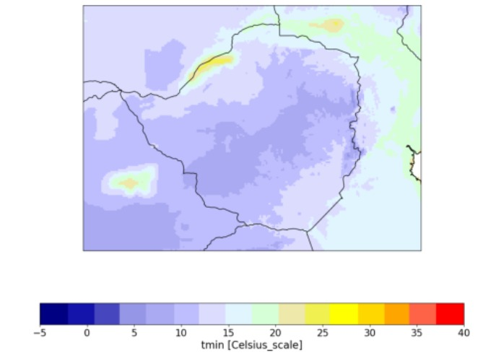

Fig 1: Minimum temperature forecast for July

As shown in Fig. 1 above, minimum temperatures for the month of July are
expected to be very low, ranging from 0 to 5 degrees Celsius in areas along the
Highveld. Ground frost is probable in these regions. Most parts of the country are
expected to have minimum temperatures below 15°C. Mild conditions are anticipated
in areas along the Zambezi Valley and the extreme districts of Matabeleland South
and Masvingo provinces.

Table 2: Provincial Weather outlook valid from 04-07-2025 to 14-07-2025
Province | Agromet -Weather forecast | Wind  Direction  & Wind  Speed  (knots) | Relative  Humidity  % | Min/Max  °C
Mashonaland  Central | Mostly sunny and warm for much of the day,with light winds from time to time. Cold both in the morning and overnight. Slight ground frost is probable in all frost prone areas. | NE’ly | 60-100 | 11-27
Mashonaland East | Mostly sunny and warm for much of the day.Cold both in the morning and overnight. Slight ground frost is probable in areas such as Marondera. | NE’ly | 60-100 | 05-25
Mashonaland West | Mostly sunny and warm for much of the day. Cold both in the morning and evening. | NE’ly | 60-100 | 11-27
Harare | Mostly sunny and warm in the afternoon. Cold both in the morning and evening. Ground frost is probable in all frost prone areas | NE’ly | 60-100 | 08-26
Midlands | Mostly sunny and warm for much of the day. Cold both in the morning and evening.Ground frost is probable in areas such as Gweru | SE’ly | 60-100 | 05-24
Manicaland | Partly cloudy and warm afternoons. Clear skies and cold mornings with a chance of slight to moderate ground frost in places like Nyanga. | SE’ly | 60-100 | 05-23
Masvingo | Mostly sunny and warm for much of the day. Cold both in the morning and evening. | SE’ly | 60-100 | 07-25
Matabeleland North | Mostly clear skies and warm for much of the day. Cold both in the morning and evening. | NE’ly | 60-100 | 12-26
Matabeleland South | Mostly sunny and warm for much of the day. Cold both in the morning and evening. Ground frost is probable in areas such as Kezi, Matopos. | SE’ly | 60-100 | 08-23
Bulawayo | Mostly clear skies and warm for much of the day. Cold both in the morning and evening. | SE’ly | 60-100 | 09-26

AGROMET ADVISORY
- Crop Protection: Cover sensitive crops (e.g., winter wheat, vegetables) with mulch , especially in frost-prone areas. Light irrigation at dawn can help reduce frost damage.

- Livestock Care: Provide windbreaks and warm drinking water for livestock, particularly young or vulnerable animals, during cold mornings and evenings.

- Frost-Prone Areas (Kezi, Matopos): Monitor temperatures closely and prioritize frost-resistant crop varieties where possible.

- Soil & Moisture Management: Retain crop residues and minimize tillage to conserve soil moisture during dry, cold conditions.

