

10 DAY AGROMET BULLETIN

SUMMARY OF THE PAST DEKAD 01-09-2025 to 10-09-2025
Sunny and hot conditions prevailed across the country during the dekad under review. Mornings were cool in most areas, with mild conditions experienced along the Zambezi Valley. Winds were predominantly south-easterly in the southern provinces, while northern areas experienced variable wind directions. Increased evaporation rates were recorded in many areas due to high daytime temperatures.

10-DAY WEATHER SUMMARY BY PROVINCE FOR THE PERIOD 01-09-2025 to 10-09-2025
Province | Station | Clouds (Oktas) | Gmin | Min/Max  Temp.  (C) |  | Relative Humidity range (%) |  | Rainfall total in 10 days (mm) | Wind direction | Wind speed (knots) | Evaporation  (mm) | Sunshine hours
Mashonaland Central  (5 Stations) | Henderson | 1 | 1 | 3 | 32 | 9 | 88 | 000 | NE | 02 | E | 099
Mashonaland Central  (5 Stations) | Mvurwi | 1 | 14 | 15 | 37 | 10 | 77 | 000 | NE | 05 | E | E
Mashonaland Central  (5 Stations) | Guruve
Mashonaland Central  (5 Stations) | Mt Darwin | 1 | E | 07 | 34 | 10 | 82 | 000 | E | 04 | E | E
Mashonaland Central  (5 Stations) | Kanyemba
Mashonaland  East  (4 Stations) | Mutoko | 1 | 05 | 10 | 31 | 10 | 90 | 000 | E | 08 | 717 | E
Mashonaland  East  (4 Stations) | Chivhu | 0 | 02 | 8 | 32 | 10 | 95 | 000 | E | E | E | E
Mashonaland  East  (4 Stations) | Marondera | 1 | E | 07 | 30 | 10 | 90 | 000 | E | E | E | E
Mashonaland  East  (4 Stations) | Wedza | 1 | 07 | 12 | 30 | 19 | 94 | 000 | WS | 04 | E | E
Mashonaland West  (6 Stations) | Chinhoyi
Mashonaland West  (6 Stations) | Chibero | 0 | E | 8 | 28 | 16 | 75 | 000 | 12 | 04 | E | E
Mashonaland West  (6 Stations) | Karoi
Mashonaland West  (6 Stations) | Kariba | 0 | 10 | 14 | 37 | 12 | 50 | 000 | SW | 07 | 696 | 991
Mashonaland West  (6 Stations) | Kadoma | 0 | E | 15 | 33 | 07 | 91 | 000 | E | 9 | E | 100
Mashonaland West  (6 Stations) | Mhondoro | 4 | 05 | 09 | 32 | 12 | 93 | 000 | SE | 03 | E | E
Harare  (2 Stations) | Belvedere | 2 | 04 | 11 | 30 | 15 | 86 | 000 | NE | 10 | 677 | 097
Harare  (2 Stations) | Kutsaga | 0 | E | 8 | 31 | 10 | 85 | 000 | ELY | 04 | 73 | 098
Midlands  (4 Stations) | Gokwe | 0 | 09 | 11 | 31 | 19 | 70 | 000 | SE | 04 | E | 104
Midlands  (4 Stations) | Gweru | 1 | 2 | 4 | 32 | 7 | 89 | 000 | SE | 07 | E | 097
Midlands  (4 Stations) | Kwekwe | 0 | E | 11 | 32 | 15 | 67 | 000 | SE | 04 | 725 | E
Midlands  (4 Stations) | Zvishavane | 1 | 12 | 15 | 32 | 10 | 91 | 000 | SE | 03 | 712 | E
Manicaland  (7 Stations) | Rusape | 1 | 7 | 9 | 29 | 9 | 90 | 000 | N | 02 | E | 101
Manicaland  (7 Stations) | Nyanga | 1 | 03 | 07 | 27 | 8 | 79 | 000 | SE | 08 | 597 | 092
Manicaland  (7 Stations) | Mukandi | 1 | E | 11 | 24 | 12 | 79 | 000 | SE | 05 | 569 | E
Manicaland  (7 Stations) | Buhera | 1 | 7 | 11 | 32 | 11 | 97 | 000 | ELY | 08 | E | E
Manicaland  (7 Stations) | Chipinge | 3 | 8 | 15 | 29 | 14 | 100 | 000 | SE | 04 | 591 | E
Manicaland  (7 Stations) | Chisengu
Manicaland  (7 Stations) | Chisumbanje | 1 | E | 15 | 33 | 20 | 94 | 000 | SE | 07 | 061 | 090
Masvingo  (6 Stations) | Makoholi | 7 | E | 05 | 34 | 9 | 93 | 000 | SE | 03 | E | E
Masvingo  (6 Stations) | Masvingo | 2 | 09 | 11 | 31 | 10 | 95 | 000 | SE | 09 | 628 | 999
Masvingo  (6 Stations) | Zaka | 1 | 09 | 14 | 32 | 9 | 91 | 000 | SE | 04 | E | E
Masvingo  (6 Stations) | Rupike | 1 | E | E | E | 35 | 97 | 000 | SE | 07 | E | E
Masvingo  (6 Stations) | Buffalo Range | 2 | 07 | 14 | 37 | 18 | 94 | 000 | SE | 05 | 465 | 085
Matabeleland  North  (6 Stations) | Binga | 0 | 13 | 18 | 35 | 14 | 69 | 000 | VRB | 03 | 840 | 100
Matabeleland  North  (6 Stations) | Lupane | 0 | E | 7 | 37 | 12 | 73 | 000 | NE | 06 | E | E
Matabeleland  North  (6 Stations) | Hwange | 1 | 07 | 12 | 37 | 11 | 61 | 000 | SE | 05 | E | 095
Matabeleland  North  (6 Stations) | Tsholotsho | 1 | E | 11 | 35 | 7 | 65 | 000 | SE | 03 | E | E
Matabeleland  North  (6 Stations) | Nkayi | 0 | 07 | 09 | 35 | 05 | 80 | 000 | SE | 06 | E | 093
Matabeleland  North  (6 Stations) | Victoria Falls | 0 | 10 | 14 | 33 | 7 | 47 | 000 | se | 08 | e | 099
Matabeleland South  (5 Stations) | Kezi
Matabeleland South  (5 Stations) | Matopos | 1 | 2 | 3 | 33 | 12 | 81 | TR | NE | 07 | E | E
Matabeleland South  (5 Stations) | Beitbridge | 1 | 10 | 14 | 39 | 12 | 85 | TR | SE | 06 | 625 | E
Matabeleland South  (5 Stations) | West Nich | 2 | 05 | 07 | 37 | E | E | 000 | SE | 06 | E | 089
Matabeleland South  (5 Stations) | Plumtree | 1 | 09 | 15 | 33 | 11 | 71 | 000 | SSE | 09 | E | E
Bulawayo | Goetz | 2 | E | 11 | 31 | 12 | 85 | 000 | 09 | 03 | 79 | 099

EVAPORATION, TEMPERATURE AND DETECTED FIRES
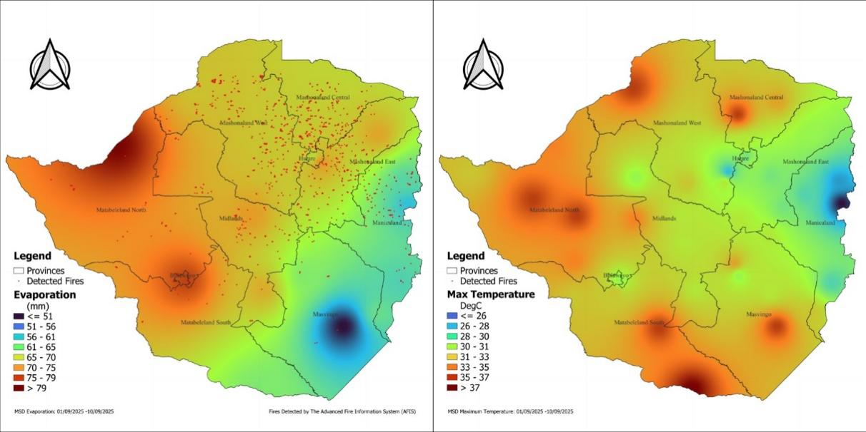
Fig 1: Evaporation and Max Temperature in the dekad ending 10-09-2025 and Active Fires Detected by the Advanced Fire Information Systems (AFIS)

In the last dekad, high evaporation rates exceeding 79 mm were recorded over parts of Matabeleland North and Bulawayo owing to higher temperatures. Lower rates below 61 mm were confined to the Eastern highlands and the central parts of Masvingo. Maximum temperatures surpassed 36°C in the southern areas of Matabeleland South and Masvingo, with cooler conditions below 26°C observed in Manicaland. Fire activity was most pronounced in the Mashonaland provinces and central areas, coinciding with zones of moderate to high day time temperatures and evaporation.

WEATHER OUTLOOK: september 2025
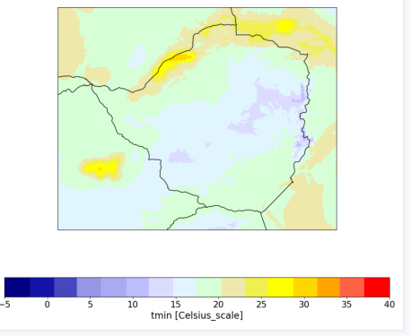 | 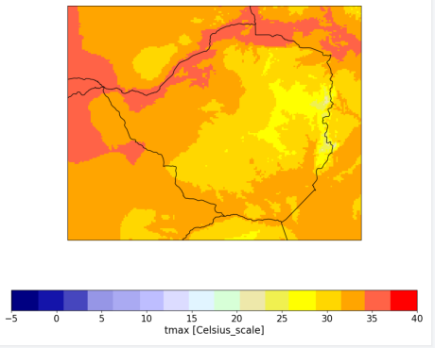
Fig 3: Maximum temperatures for the month of September.
Fig 2: Minimum temperatures for the month of
September.

As illustrated in Figure 2, minimum September temperatures are projected to be within the mild range across many parts of the country, although the extreme northern districts are expected to be in the warm range. For maximum temperatures (Figure 3), which indicate hotter afternoon conditions, much of the country will likely experience readings between 30°C and 35°C. Exceptions include parts of the Zambezi and Sabi valleys, where temperatures may exceed 36°C.
Table 2: Provincial Weather outlook valid from 13-09-2025 to 23-09-2025
Province | Agromet -Weather forecast | Wind Direction  & Wind Speed  (knots) | Relative  Humidity  (%) | Min/Max  (°C)
Mashonaland  Central | Sunny and hot in the afternoon, mild in the morning. | VRB | 80-100 | 15-34
Mashonaland East | Sunny and hot in the afternoon, cool in the morning and evening. | VRB | 80-100 | 10-30
Mashonaland West | Sunny and hot in the afternoon, cool in the morning and evening. | VRB | 80-100 | 15-35
Harare | Mostly sunny and hot in the afternoon, cool in the morning and evening. | VRB | 80-100 | 12-32
Midlands | Sunny and hot for much of the day. Cool, both in the morning and evening. | SE’ly | 80-100 | 10-29
Manicaland | Sunny and hot in the afternoon, cool in the morning. | SE’ly | 80-100 | 08-27
Masvingo | Sunny and hot in the afternoon, cool in the morning and evening. | SE’ly | 80-100 | 12-30
Matabeleland North | Sunny and hot in the afternoon, cool in the morning and evening. | VRB | 80-100 | 14-32
Matabeleland South | Sunny and hot in the afternoon, cool in the morning and evening. | SE’ly | 80-100 | 11-30
Bulawayo | Sunny and hot in the afternoon, cool in the morning and evening. | SE’ly | 80-100 | 12-31

AGROMET ADVISORY
The forecasted hot and sunny conditions necessitate a focus on water conservation and heat stress mitigation. The following actions are recommended to protect crops, livestock, and workers:
- Field Crops mites (e.g., Maize, Soybeans)
- Ensure adequate soil moisture to help crops cope with afternoon heat stress.
- Monitor for pests like spider that thrive in hot, dry conditions.
- Moisture Conservation: High evaporation rates will rapidly deplete soil water reserves. Implement water conservation practices such as mulching to reduce soil temperature and conserve moisture.
- Horticulture (Vegetables, Fruits)
- Irrigate deeply in the early morning to minimize water loss from evaporation.
- Watch for sunscald on tender fruits and vegetables during peak afternoon heat.
- Livestock Management
- Provide ample shade and cool, clean water to prevent heat stress.
- Avoid handling or moving animals during the hottest part of the day.
- General Operations
- Schedule outdoor farm work for the cooler morning hours.
- Be aware of an increased fire risk due to dry, hot conditions.

2025/2026 SEASONAL RAINFALL OUTLOOK
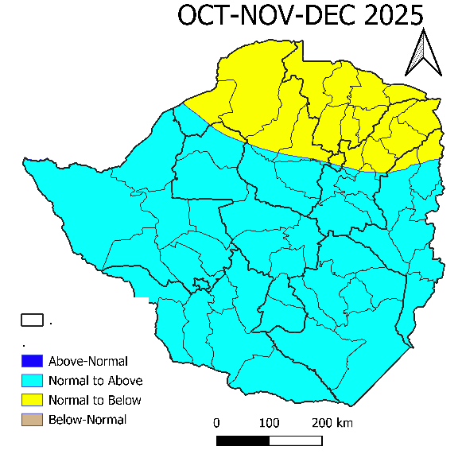
OCTOBER-NOVEMBER-DECEMBER 2025
- The northern and western parts are expected to receive normal to below-normal rainfall.
- The southern and eastern parts are expected to receive normal to above-normal rainfall.

MONTHLY BREAKDOWN FORECAST: OCTOBER-NOVEMBER-DECEMBER
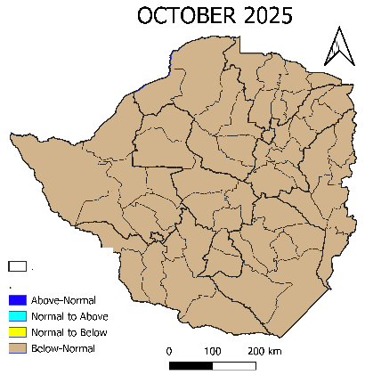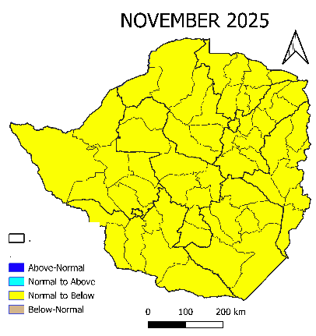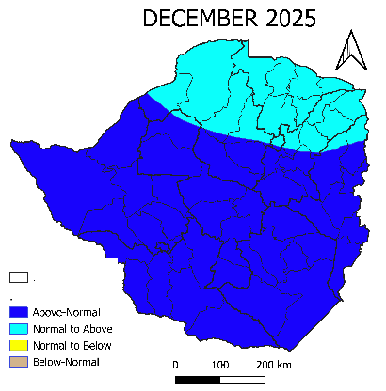
- A delayed onset of season is projected as the monthly forecasts indicates that below normal rainfall is expected during the month of October and November 2025. Increased chance of normal to above in the northern parts of the country is projected in December while the rest of the country is expected to have an increased chance of above normal rainfall.
JANUARY-FEBRUARY-MARCH 2026
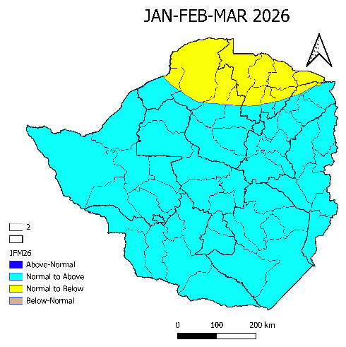
For the period January to March, rainfall forecast indicates an increased chance of normal to above-normal rainfall in the bulk of the country. Except for northern parts, covering the bulk of Mashonaland Central and northern parts of Mashonaland West and East, has an increased chance of normal to below-normal rainfall.

Overall Implication: A Delayed and Potentially Compressed Season
The core issue is the delayed onset, which shortens the growing season and disrupts standard agricultural calendars.
1. Implications for October-November (Below-Normal Rainfall)
This early period is critical for land preparation and planting.
- Delayed Planting: Farmers will be unable to plant at the usual time. Waiting for sufficient soil moisture delays the entire crop cycle.
- Poor Seed Germination: Even if planting occurs, below-normal rain leads to inadequate soil moisture, causing poor and uneven germination, leading to patchy stands and the need for costly replanting.
- Increased Cost of Production: Farmers may be forced to rely on irrigation where available, significantly increasing costs for water, fuel, and electricity.
- Water Stress for Perennials: Tree crops (e.g., coffee, fruits) and forage pastures may experience early-season water stress, affecting flowering and development.
- Increased Pest Risk: Stressed young plants can be more susceptible to pest attacks
2. Implications for December (Shift to Normal/Above-Normal Rainfall)
The sudden shift, while providing needed water, brings its own set of challenges.
For the Northern Parts (Normal to Above-Normal):
- Beneficial Recovery: This rainfall will be highly beneficial, allowing for successful planting and crop establishment, though later than usual.
- Good Vegetative Growth: Crops will likely experience vigorous vegetative growth under the improved moisture conditions
For the Rest of the Country (Above-Normal Rainfall):
- Water-logging and Flooding: Intense rainfall on dry, hard-baked soil can lead to poor infiltration, causing runoff, water-logging, and flooding of fields. This can drown young plants and leach nutrients from the soil.
- Soil Erosion: Heavy rains on unprepared land can cause significant soil erosion, stripping away fertile topsoil.
- Leaching of Fertilizers: Applied fertilizers (especially nitrates) can be leached below the root zone, reducing their efficiency and polluting groundwater.
- Disruption of Field Activities: It will be difficult to access fields for mechanized activities, spraying, or weeding.
- Disease Outbreaks: The combination of late-planted, vulnerable crops and a humid, wet environment creates ideal conditions for the spread of fungal and bacterial diseases.

RECOMMENDATIONS
To adapt to these challenges, farmers should adopt a flexible and proactive approach. Key recommendations include:
- To counter the delayed start, farmers should prioritize short-season and drought-tolerant crop varieties to ensure a harvest within the compressed time-frame. Practicing water conservation techniques like mulching is essential to preserve precious soil moisture.
- In anticipation of heavy December rains, preparing drainage channels in fields is critical to prevent water-logging and erosion.
- Nutrient management should be adjusted; applying fertilizer in split doses after the rains have stabilized, rather than all at once at planting, will prevent leaching and improve efficiency.
- Finally, farmers must be vigilant for pests and diseases. Implementing close monitoring and having appropriate organic or chemical controls ready will be necessary to protect crops during the wet period.
NB : The Meteorological Services Department will continue to monitor seasonal climate indicators which influence Zimbabwe’s rainfall as they evolve. Thus, the seasonal rainfall predictions will be updated on a monthly basis. starting the end of October. In addition, there will be daily weather forecasts and 10-day weather bulletins that will take into account any changes. A seasonal forecast is a long-term planning tool and therefore it doesn’t replace the need for short term forecasts which are key for capturing the occurrence of short-term weather events such as dry spells, actual onset of season which can not be captured in a seasonal forecast.

