

10 DAY AGROMET BULLETIN

SUMMARY OF THE PAST DEKAD 21-09-2025 to 30-09-2025
The weather during the last dekad of September was characterized by predominantly sunny and hot conditions. The highlight was rainfall in some areas, resulting from a cloud band that entered the country from Botswana and swept across it. The highest cumulative rainfall was recorded in areas such as Rusape (50 mm), Chisengu (32 mm), Karoi (26 mm), Beitbridge (14 mm), Chisumbanje (12 mm), and Mukandi (11 mm).
Towards the end of the dekad, the southern provinces including Masvingo, Matabeleland South, Manicaland, and the southern parts of Midlands experienced cloudy and windy conditions. This was due to a high-pressure system over the east coast of the subcontinent, which brought moist south-easterlies. In contrast, the northern provinces experienced a north-easterly airflow for much of the period. Evaporation rates were somewhat lower, particularly in the southern provinces, because of the prevailing cloudy conditions.

10-DAY WEATHER SUMMARY BY PROVINCE FOR THE PERIOD 21-09-2025 to 30-09-2025
Province | Station | Clouds (Oktas) | Gmin | Min/Max Temp (C) |  | Relative Humidity range (%) |  | Rainfall total in 10 days (mm) | Wind direction | Wind speed (knots) | Evaporation (mm) | Sunshine hours
Mashonaland Central  (5 Stations) | Henderson | 2 | 05 | 06 | 33 | 17 | 94 | 8.2 | NE | 03 | - | -
Mashonaland Central  (5 Stations) | Mvurwi | 2 | - | 14 | 29 | 18 | 88 | - | NE | 03 | - | -
Mashonaland Central  (5 Stations) | Guruve
Mashonaland Central  (5 Stations) | Mt Darwin | 1 | - | 13 | 36 | 15 | 90 | - | NE | 04 | - | -
Mashonaland Central  (5 Stations) | Kanyemba | 3 | 18 | 20 | 40 | 10 | 67 | - | NE | 07 | - | -
Mashonaland  East  (4 Stations) | Mutoko | 1 | 08 | 11 | 34 | 15 | 97 | -- | NE | 07 | 54.7 | -
Mashonaland  East  (4 Stations) | Chivhu
Mashonaland  East  (4 Stations) | Marondera | 2 | - | 06 | 32 | 13 | 100 | -- | NE | 02 | - | -
Mashonaland  East  (4 Stations) | Wedza | 2 | 11 | 13 | 31 | 13 | 100 | 4.8 | SW | 06 | - | -
Mashonaland West  (6 Stations) | Chinhoyi | 2 | - | 16 | 22 | 12 | 85 | 5.5 | NE | 03 | - | -
Mashonaland West  (6 Stations) | Chibero | 2 | - | 15 | 32 | 24 | 93 | - | NE | 09 | - | -
Mashonaland West  (6 Stations) | Karoi | 1 | 14 | 15 | 32 | 21 | 88 | 26.0 | SE | 07 | - | -
Mashonaland West  (6 Stations) | Kariba | 2 | 12 | 21 | 41 | 12 | 50 | - | VRB | 07 | 74.6 | 093
Mashonaland West  (6 Stations) | Kadoma | 1 | - | 17 | 33 | 13 | 81 | - | E | 07 | - | 093
Mashonaland West  (6 Stations) | Mhondoro | 1 | - | 17 | 35 | 15 | 88 | - | SE | 02 | - | -
Harare  (2 Stations) | Belvedere | 2 | 05 | 12 | 31 | 20 | 94 | - | NE | 08 | 71.9 | 087
Harare  (2 Stations) | Kutsaga | 1 | - | 09 | 32 | 17 | 94 | - | SE | 05 | 75.2 | 087
Midlands  (4 Stations) | Gokwe | 1 | 11 | 16 | 34 | 16 | 82 | -- | SE | 08 | - | -
Midlands  (4 Stations) | Gweru | 2 | 04 | 07 | 33 | 13 | 95 | 0.1 | SE | 08 | - | 076
Midlands  (4 Stations) | Kwekwe | 1 | - | 14 | 32 | 26 | 77 | 0.6 | SE | 04 | 72.9 | -
Midlands  (4 Stations) | Zvishavane | 3 | 14 | 15 | 30 | 43 | 82 | 3.7 | SE | 04 | 61.7 | -
Manicaland  (7 Stations) | Rusape | 2 | 10 | 13 | 29 | 12 | 97 | 49.6 | NE | 03 | - | 100
Manicaland  (7 Stations) | Nyanga | 3 | 00 | 03 | 28 | 13 | 100 | 0.2 | NE | 03 | 51.4 | 088
Manicaland  (7 Stations) | Mukandi | 4 | - | 11 | 24 | 18 | 100 | 11.0 | SE | 05 | - | 075
Manicaland  (7 Stations) | Buhera | 2 | 09 | 13 | 31 | 13 | 100 | 0.3 | SE | 06 | + | +
Manicaland  (7 Stations) | Chipinge | 4 | 12 | 13 | 33 | 26 | 100 | 1.8 | SE | 04 | 44.4 | 064
Manicaland  (7 Stations) | Chisengu | 4 | - | - | 34 | 13 | 100 | 31.5 | SE | 04 | - | -
Manicaland  (7 Stations) | Chisumbanje | 3 | - | 17 | 30 | 19 | 100 | 11.7 | SE | 08 | 38.1 | 061
Masvingo  (6 Stations) | Makoholi | 1 | - | 09 | 36 | 15 | 96 | 0.1 | SE | 03 | - | -
Masvingo  (6 Stations) | Masvingo | 3 | 09 | 12 | 37 | 11 | 94 | 0.4 | SE | 07 | 74.0 | 054
Masvingo  (6 Stations) | Zaka | 2 | 13 | 16 | 29 | 15 | 97 | 7.6 | SE | 04 | - | -
Masvingo  (6 Stations) | Rupike | 4 | - | - | - | 32 | 75 | 0.7 | SE | 04 | - | -
Masvingo  (6 Stations) | Buffalo Range | 4 | 04 | 16 | 37 | 17 | 100 | 3.8 | SE | 05 | 43.8 | 060
Matabeleland  North  (6 Stations) | Binga | 1 | 12 | 22 | 37 | 21 | 26 | - | NE | 05 | 93.4 | 087
Matabeleland  North  (6 Stations) | Lupane
Matabeleland  North  (6 Stations) | Hwange | 1 | 12 | 14 | 35 | 13 | 80 | - | VRB | 11 | - | 089
Matabeleland  North  (6 Stations) | Tsholotsho
Matabeleland  North  (6 Stations) | Nkayi | 2 | 11 | 14 | 36 | 07 | 86 | - | SE | 05 | - | 091
Matabeleland  North  (6 Stations) | Victoria Falls | 2 | 16 | 19 | 35 | 08 | 82 | 7.0 | NE | 08 | - | 089
Matabeleland South  (5 Stations) | Kezi
Matabeleland South  (5 Stations) | Matopos | 3 | 13 | 14 | 35 | 11 | 94 | - | SE | 09 | - | -
Matabeleland South  (5 Stations) | Beitbridge | 3 | 12 | 16 | 39 | 15 | 97 | 14.2 | SE | 08 | - | -
Matabeleland South  (5 Stations) | West Nich | 4 | 09 | 10 | 40 | - | - | 1.6 | SE | 08 | - | -
Matabeleland South  (5 Stations) | Plumtree | 2 | 13 | 15 | 35 | 12 | 91 | 3.0 | SE | 08 | - | -
Bulawayo | Goetz | 2 | - | 14 | 30 | 33 | 70 | 1.5 | Se | 05 | 59.4 | 072

EVAPORATION, TEMPERATURE AND PRECIPITATION
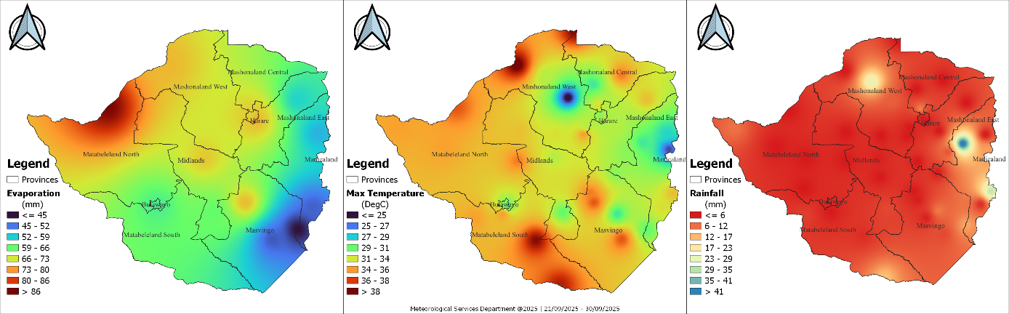
Fig 1: Evaporation, Maximum Temperature and Rainfall in the dekad ending 30-09-2025

The maps show evaporation, maximum temperature, and rainfall patterns over Zimbabwe for 21–30 September 2025. Evaporation was highest in the northern and western parts of the country, exceeding 70 mm, while lower values were observed in the south and east. Maximum temperatures were mostly above 32°C, with the hottest conditions above 35°C affecting large parts of the country. Rainfall was very limited, with most areas receiving less than 6 mm, except for isolated pockets in Mashonaland and Manicaland where 12–23 mm was recorded.

WEATHER OUTLOOK: October 2025
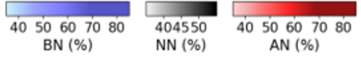  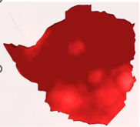 | 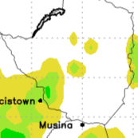  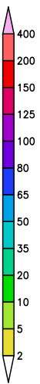  Fig 3: Weather outlook from 03-10-25 to 13-10-25. Courtesy https://www.weatherphotos.co.za
Fig 2: Temperature Outlook for October

As shown in Figure 2, temperatures for October are forecast to be above normal across much of the country, as indicated by the widespread dark red on the map. Figure 3 shows the cumulative rainfall forecast for the first dekad of October, indicating that isolated thundershowers are expected in some areas. Total rainfall is projected to be less than 20 mm for most of the country, though localized downpours are probable.
Table 2: Provincial Weather outlook valid from 03-10-2025 to 13-10-2025
Province | Agromet -Weather forecast | Wind Direction  & Wind Speed  (knots) | Relative  Humidity  (%) | Min/Max  (°C)
Mashonaland Central | Mostly sunny and hot in the afternoon mild in the morning. Partly cloudy conditions with a chance of Isolated thundershowers are expected towards the end of the dekad. | NE’ly | 80-100 | 14-32
Mashonaland East | Mostly sunny and hot in the afternoon mild in the morning. Partly cloudy conditions with a chance of Isolated thundershowers are expected towards the end of the dekad. | NE’ly | 80-100 | 10-30
Mashonaland West | Mostly sunny and hot in the afternoon mild in the morning. Partly cloudy conditions with a chance of Isolated thundershowers are expected towards the end of the dekad. | NE’ly | 80-100 | 15-35
Harare | Mostly sunny and hot in the afternoon mild in the morning. Partly cloudy conditions with a chance of Isolated thundershowers are expected towards the end of the dekad. | NE’ly | 80-100 | 10-32
Midlands | Mostly sunny and hot in the afternoon mild in the morning. Partly cloudy conditions with a chance of Isolated thundershowers are expected towards the end of the dekad. | SE’ly | 80-100 | 10-29
Manicaland | Briefly cloudy and warm in the morning, becoming mostly sunny and hot in the afternoon for much of the dekad.  Towards the end of the dekad cloudy, windy and drizzly conditions are expected. | SE’ly | 80-100 | 08-27
Masvingo | Briefly cloudy and warm in the morning, becoming mostly sunny and hot in the afternoon for much of the dekad.  Towards the end of the dekad cloudy, windy and drizzly conditions are expected. | SE’ly | 80-100 | 12-30
Matabeleland North | Mostly sunny and hot in the afternoon mild in the morning. Partly cloudy and hot conditions with a chance of Isolated thundershowers are expected towards the end of the dekad. | NE’ly | 80-100 | 14-32
Matabeleland South | Briefly cloudy and warm in the morning, becoming mostly sunny and hot in the afternoon for much of the dekad.  Towards the end of the dekad cloudy, windy and drizzly conditions are expected. | SE’ly | 80-100 | 11-30
Bulawayo | Briefly cloudy and warm in the morning, becoming mostly sunny and hot in the afternoon for much of the dekad.  Towards the end of the dekad cloudy, windy and drizzly conditions are expected. | SE’ly | 80-100 | 12-31

AGROMET ADVISORY
- Dryland Farming (Land Preparation & Input Procurement):
  - Advisory: This is a critical window for land preparation and securing inputs. Given the uncertain and isolated nature of the forecasted rainfall, farmers are strongly advised to consult with their local Agritex officers for personalized, location-specific guidance on the optimal timing for sowing and other management practices.
- Early Planted & Irrigated Crops (Maize and Tobacco):
  - Advisory: Farmers with irrigated maize and tobacco should continue with normal irrigation schedules to support crop growth, as the forecasted rain will provide negligible supplementary water.
- Advisory on Extreme Weather Events:
The potential for severe weather associated with isolated thunderstorms requires preparedness.
  - Localized Heavy Downpours: These can cause waterlogging in seedbeds, nutrient leaching in prepared fields, and rapid surface runoff leading to soil erosion. Ensure drainage systems are clear.
  - Lightning: This is a serious safety risk. Advise all farmers and workers to seek shelter indoors immediately when thunder is heard. Do not continue field operations during a thunderstorm.
  - Hail: Hail can cause significant physical damage to young, exposed crops and tobacco seedlings. Where possible, farmers with sensitive, high-value irrigated crops (like tobacco) should monitor forecasts and be prepared to use protective hail nets if available and feasible.
- General Recommendations:
  - Utilize Rainfall Events: While overall amounts will be low, any received rainfall can be beneficial for moistening seedbeds.
  - Monitor Official Forecasts: Stay updated with daily weather bulletins for signs of a significant shift in rainfall patterns.
  - Seek Expert Advice: Regular consultation with Agritex officers is recommended to navigate the current season's variability effectively.

