

10 DAY AGROMET BULLETIN

SUMMARY OF THE PAST DEKAD 01-10-2025 to 10-10-2025
Mostly sunny and hot conditions prevailed across the country during the first dekad of October. Isolated thundershowers, resulting from a weak cloud band that entered from the west and a high-pressure system over the subcontinent's south-east coast, brought light rain and drizzle to the southern provinces. The highest rainfall amounts recorded were 19 mm in Nyanga and 8 mm in Chisengu. The highest maximum temperature recorded was 39 degrees Celsius in areas such as Kanyemba, Kariba, Lupane, and Beitbridge. Southern provinces experienced a south-easterly airflow, driven by cool south-easterlies that were dominant early in the dekad; in contrast, a north-easterly airflow dominated the northern provinces. High daytime temperatures resulted in elevated evaporation rates across most of the country

10-DAY WEATHER SUMMARY BY PROVINCE FOR THE PERIOD 01-10-2025 to 10-10-2025
Province | Station | Clouds (Oktas) | Min/Max  Temp.  (C) |  | Relative Humidity range (%) |  | Rainfall total in 10 days (mm) | Wind direction | Wind speed (knots) | Evaporation  (mm) | Sunshine hours
Mashonaland Central  (5 Stations) | Henderson | 1 | 06 | 33 | 15 | 97 | - | NE | 03 | - | 105
Mashonaland Central  (5 Stations) | Mvurwi
Mashonaland Central  (5 Stations) | Guruve | 1 | 11 | 34 | 15 | 85 | - | NE | 10 | - | -
Mashonaland Central  (5 Stations) | Mt Darwin | 1 | 11 | 35 | 10 | 94 | - | E | 05 | - | -
Mashonaland Central  (5 Stations) | Kanyemba | 1 | 17 | 39 | 17 | 67 | - | NE | 07 | - | -
Mashonaland  East  (4 Stations) | Mutoko | 2 | 10 | 31 | 16 | 97 | - | E | 08 | 71.3 | -
Mashonaland  East  (4 Stations) | Chivhu | 3 | 06 | 34 | 15 | 100 | - | E | 03 | - | -
Mashonaland  East  (4 Stations) | Marondera | 2 | 03 | 31 | 10 | 97 | - | NE | 03 | - | -
Mashonaland  East  (4 Stations) | Wedza | 2 | 12 | 29 | 13 | 100 | - | W | 07 | - | -
Mashonaland West  (6 Stations) | Chinhoyi | 1 | 15 | 32 | 12 | 85 | - | NE | 03 | - | -
Mashonaland West  (6 Stations) | Chibero | 2 | 10 | 30 | 24 | 57 | - | NE | 09 | - | -
Mashonaland West  (6 Stations) | Karoi | 7 | 14 | 27 | 18 | 94 | - | E | 07 | - | 106
Mashonaland West  (6 Stations) | Kariba | 1 | 19 | 39 | 20 | 69 | - | VRB | 13 | 68.7 | 107
Mashonaland West  (6 Stations) | Kadoma | 1 | 15 | 33 | 10 | 82 | - | E | 09 | - | 097
Mashonaland West  (6 Stations) | Mhondoro | 2 | 09 | 35 | 09 | 85 | 2.7 | SE | 02 | - | -
Harare  (2 Stations) | Belvedere | 1 | 10 | 32 | 16 | 91 | - | NE | 05 | 69.1 | -
Harare  (2 Stations) | Kutsaga | 1 | 06 | 32 | 09 | 93 | - | E | 05 | 77.1 | 097
Midlands  (4 Stations) | Gokwe | 1 | 13 | 35 | 11 | 80 | 0- | NE | 02 | - | 105
Midlands  (4 Stations) | Gweru | 2 | 06 | 33 | 11 | 97 | - | SE | 06 | - | 093
Midlands  (4 Stations) | Kwekwe
Midlands  (4 Stations) | Zvishavane | 2 | 15 | 30 | 28 | 79 | - | SE | 08 | 69.0 | -
Manicaland  (7 Stations) | Rusape | 1 | 12 | 27 | 13 | 94 | - | SE | 02 | - | 105
Manicaland  (7 Stations) | Nyanga | 2 | 08 | 22 | 10 | 96 | 18.6 | SE | 05 | 51.4 | 098
Manicaland  (7 Stations) | Mukandi | 2 | 09 | 23 | 21 | 100 | 2.5 | E | 05 | 50.8 | 090
Manicaland  (7 Stations) | Buhera | 1 | 06 | 35 | 10 | 94 | - | SE | 01 | - | -
Manicaland  (7 Stations) | Chipinge | 3 | 10 | 31 | 24 | 100 | 4.1 | SE | 04 | 52.1 | 087
Manicaland  (7 Stations) | Chisengu | 2 | - | 32 | 31 | 100 | 7.7 | SE | 03 | - | -
Manicaland  (7 Stations) | Chisumbanje | 2 | 16 | 31 | 15 | 94 | -- | SE | 08 | 74.1 | 088
Masvingo  (6 Stations) | Makoholi | 2 | 06 | 35 | 11 | 97 | - | Vrb | 03 | - | -
Masvingo  (6 Stations) | Masvingo | 2 | 05 | 35 | 13 | 100 | - | SE | 08 | 71.9 | 097
Masvingo  (6 Stations) | Zaka | 3 | 14 | 31 | 14 | 97 | - | SE | 03 | - | -
Masvingo  (6 Stations) | Rupike | 3 | - | - | 43 | 86 | - | SE | 09 | - | -
Masvingo  (6 Stations) | Buffalo Range | 3 | 12 | 38 | 19 | 97 | - | SE | 05 | 50.9 | 082
Matabeleland  North  (6 Stations) | Binga | 1 | 21 | 37 | 15 | 67 | - | VRB | 05 | 100.0 | 107
Matabeleland  North  (6 Stations) | Lupane | 1 | 08 | 39 | 10 | 87 | - | SE | 04 | - | -
Matabeleland  North  (6 Stations) | Hwange | 1 | 13 | 37 | 13 | 76 | - | NE | 07 | - | 084
Matabeleland  North  (6 Stations) | Tsholotsho | 1 | 09 | 38 | 10 | 87 | - | E | 04 | - | -
Matabeleland  North  (6 Stations) | Nkayi | 1 | 09 | 37 | 09 | 90 | - | SE | 05 | - | 094
Matabeleland  North  (6 Stations) | Victoria Falls | 1 | 16 | 37 | 13 | 79 | - | E | 10 | - | 104
Matabeleland South  (5 Stations) | Kezi
Matabeleland South  (5 Stations) | Matopos | 1 | 09 | 35 | 12 | 84 | - | E | 05 | - | -
Matabeleland South  (5 Stations) | Beitbridge | 3 | 13 | 39 | 15 | 88 | - | SE | 07 | 74.0 | -
Matabeleland South  (5 Stations) | West Nicholson | 3 | 05 | 38 | - | - | 1.3 | SE | 05 | - | 085
Matabeleland South  (5 Stations) | Plumtree | 2 | 09 | 36 | 15 | 92 | 0 | SE | 09 | - | -
Bulawayo | Goetz | 2 | 08 | 35 | 13 | 95 | - | SE | 02 | 81.1 | 098

EVAPORATION, TEMPERATURE AND PRECIPITATION

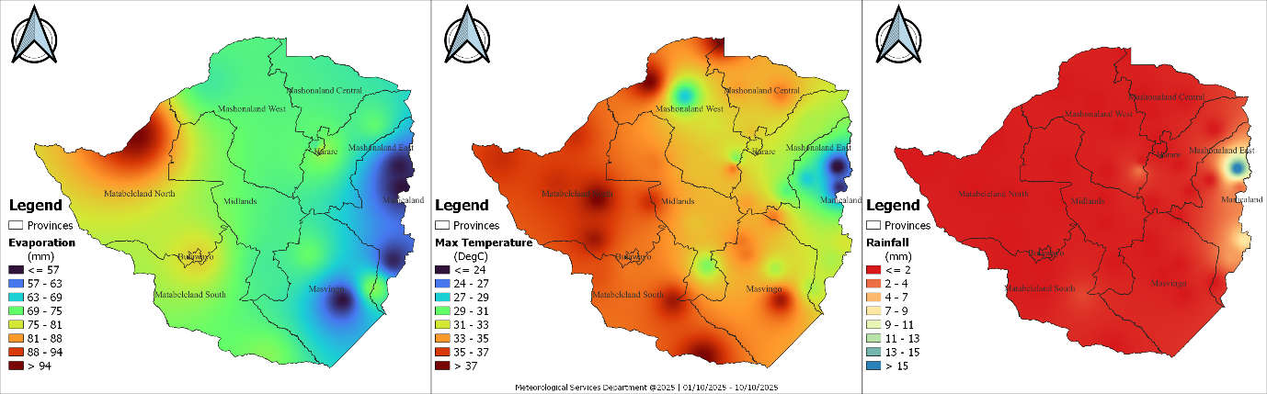
Fig 1: Evaporation, Maximum Temperature and Rainfall in the dekad ending 10-10-2025

Dry and hot conditions persisted during the review period (Fig 1). Evaporation was highest in the western and southern parts of the country with the highest of 100 mm being observed in Binga, aligning with zones of elevated maximum temperatures above 33°C. Most areas received meaningful rainfall, with only isolated light falls in parts of Manicaland. The combination of high temperatures, strong evaporation, and little rainfall reflects a typical transition toward the onset of the rainfall season.

WEATHER OUTLOOK: October 2025
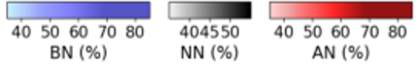  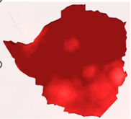 | 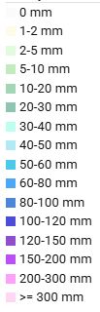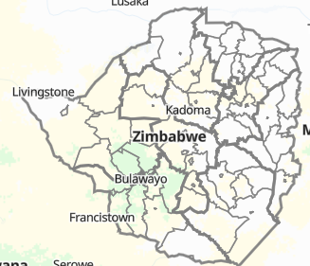  Fig 3: Weather outlook from 11-10-25 to 20-10-25. Courtesy https://prism.zwe.wfp.org/
Fig 2: Temperature Outlook for October

As illustrated in Figure 2, temperatures for October are forecast to be above normal across much of the country, as indicated by the widespread dark red on the map. Figure 3 shows the cumulative rainfall forecast for the second dekad of October, indicating that isolated thundershowers are expected in some areas. The 10-day rainfall toatal is projected to be less than 20 mm for most of the country, though localized downpours are probable.
Table 2: Provincial Weather outlook valid from 14-10-2025 to 24-10-2025
Province | Agromet -Weather forecast | Wind Direction  & Wind Speed  (knots) | Relative  Humidity  (%) | Min/Max  (°C)
Mashonaland Central | Partly cloudy and mild in the morning, becoming hot with isolated thundershowers in the afternoon. | NE’ly | 80-100 | 14-36
Mashonaland East | Partly cloudy and mild in the morning, becoming hot with isolated thundershowers in the afternoon. | NE’ly | 80-100 | 10-32
Mashonaland West | Partly cloudy and mild in the morning, becoming hot with isolated thundershowers in the afternoon. | NE’ly | 80-100 | 15-35
Harare | Partly cloudy and mild in the morning, becoming hot with isolated thundershowers in the afternoon. | NE’ly | 80-100 | 10-33
Midlands | Partly cloudy and mild in the morning, becoming hot with isolated thundershowers in the afternoon. | SE’ly | 80-100 | 10-33
Manicaland | Briefly cloudy and warm in the morning, becoming mostly sunny and hot in the afternoon for much of the dekad.  Towards the end of the dekad cloudy, windy and drizzly conditions are expected. | SE’ly | 80-100 | 08-27
Masvingo | Briefly cloudy and warm in the morning, becoming mostly sunny and hot in the afternoon for much of the dekad.  Towards the end of the dekad cloudy, windy and drizzly conditions are expected. | SE’ly | 80-100 | 12-34
Matabeleland North | Partly cloudy and mild in the morning, becoming hot with isolated thundershowers in the afternoon. | NE’ly | 80-100 | 14-36
Matabeleland South | Briefly cloudy and warm in the morning, becoming mostly sunny and hot in the afternoon for much of the dekad.  Towards the end of the dekad cloudy, windy and drizzly conditions are expected. | SE’ly | 80-100 | 11-34
Bulawayo | Briefly cloudy and warm in the morning, becoming mostly sunny and hot in the afternoon for much of the dekad.  Towards the end of the dekad cloudy, windy and drizzly conditions are expected. | SE’ly | 80-100 | 12-35

AGROMET ADVISORY
- Dryland Farming (Land Preparation & Input Procurement):
  - Advisory: This is a critical window for land preparation and securing inputs. Given the uncertain and isolated nature of the forecasted rainfall, farmers are strongly advised to consult with their local Agritex officers for personalized, location-specific guidance on the optimal timing for sowing and other management practices.
- Early Planted & Irrigated Crops (Maize and Tobacco):
  - Advisory: Farmers with irrigated maize and tobacco should continue with normal irrigation schedules to support crop growth, as the forecasted rain will provide negligible supplementary water.
- Advisory on Extreme Weather Events:
The potential for severe weather associated with isolated thunderstorms requires preparedness.
  - Localized Heavy Downpours: These can cause waterlogging in seedbeds, nutrient leaching in prepared fields, and rapid surface runoff leading to soil erosion. Ensure drainage systems are clear.
  - Lightning: This is a serious safety risk. Advise all farmers and workers to seek shelter indoors immediately when thunder is heard. Do not continue field operations during a thunderstorm.
  - Hail: Hail can cause significant physical damage to young, exposed crops and tobacco seedlings. Where possible, farmers with sensitive, high-value irrigated crops (like tobacco) should monitor forecasts and be prepared to use protective hail nets if available and feasible.
- General Recommendations:
  - Utilize Rainfall Events: While overall amounts will be low, any received rainfall can be beneficial for moistening seedbeds.
  - Monitor Official Forecasts: Stay updated with daily weather bulletins for signs of a significant shift in rainfall patterns.
  - Seek Expert Advice: Regular consultation with Agritex officers is recommended to navigate the current season's variability effectively.

