

10 DAY AGROMET BULLETIN

SUMMARY OF THE PAST DEKAD 11-10-2025 to 21-10-2025
Mostly sunny and hot conditions prevailed across the country during the first dekad of October. Isolated thundershowers, resulting from a weak cloud band that entered from the west and a high-pressure system over the subcontinent's south-east coast, brought light rain and drizzle to the southern provinces. The highest rainfall amounts recorded were 17 mm in West Nicholson, 16 mm in Matopos, 15mm in Kezi, 14mm in Chipinge and 09mm in Kutsaga. The highest maximum temperature recorded was 41 degrees Celsius in areas such as Kanyemba. Southern provinces experienced a south-easterly airflow, driven by cool south-easterlies that were dominant early in the dekad; in contrast, a north-easterly airflow dominated the northern provinces. High daytime temperatures resulted in elevated evaporation rates across most of the country

10-DAY WEATHER SUMMARY BY PROVINCE FOR THE PERIOD 11-10-2025 to 21-10-2025
Province | Station | Clouds (Oktas) | Min/Max  Temp.  (C) |  | Relative Humidity range (%) |  | Rainfall total in 10 days (mm) | Wind direction | Wind speed (knots) | Evaporation  (mm) | Sunshine hours | Vegetation  Condition  (Rain-fed)
Mashonaland Central  (5 Stations) | Henderson | 1 | 09 | 34 | 20 | 89 | - | SE | 03 | - | 107
Mashonaland Central  (5 Stations) | Mvurwi | 1 | 14 | 30 | 18 | 88 | - | NE | 03 | - | -
Mashonaland Central  (5 Stations) | Guruve
Mashonaland Central  (5 Stations) | Mt Darwin | 1 | 14 | 36 | 16 | 84 | 00 | SE | 03 | - | -
Mashonaland Central  (5 Stations) | Kanyemba | 1 | 22 | 41 | 16 | 65 | 00 | NE | 08 | - | -
Mashonaland  East  (4 Stations) | Mutoko | 1 | 19 | 33 | 19 | 85 | - | E | 09 | 84.4 | -
Mashonaland  East  (4 Stations) | Chivhu
Mashonaland  East  (4 Stations) | Marondera | 2 | 09 | 32 | 14 | 94 | 0.1 | NE | 01 | - | -
Mashonaland  East  (4 Stations) | Wedza | 1 | 15 | 32 | 19 | 97 | 0.3 | SW | 06 | - | -
Mashonaland West  (6 Stations) | Chinhoyi | 1 | 18 | 33 | 11 | 70 | - | NE | 03 | - | -
Mashonaland West  (6 Stations) | Chibero | 1 | 16 | 33 | 16 | 65 | - | NE | 06 | - | -
Mashonaland West  (6 Stations) | Karoi | 1 | 17 | 32 | 16 | 80 | - | E | 06 | - | 103
Mashonaland West  (6 Stations) | Kariba | 1 | 22 | 40 | 13 | 59 | - | VRB | 07 | 81.9 | 106
Mashonaland West  (6 Stations) | Kadoma | 2 | 19 | 35 | 10 | 72 | - | E | 09 | - | 098
Mashonaland West  (6 Stations) | Mhondoro | 1 | 13 | 36 | 24 | 76 | - | SE | 02 | - | -
Harare  (2 Stations) | Belvedere | 1 | 15 | 32 | 22 | 89 | 5.1 | NE | 05 | 79.0 | 091
Harare  (2 Stations) | Kutsaga | 2 | 14 | 32 | 17 | 88 | 089 | SE | 04 | 85.1 | 102
Midlands  (4 Stations) | Gokwe | 2 | 18 | 36 | 17 | 68 | - | NE | 06 | - | -
Midlands  (4 Stations) | Gweru | 2 | 12 | 34 | 16 | 98 | 0.3 | SE | 07 | - | 094
Midlands  (4 Stations) | Kwekwe | 1 | 17 | 34 | 20 | 65 | - | SE | 05 | 86.9 | -
Midlands  (4 Stations) | Zvishavane | 2 | 19 | 33 | 27 | 70 | 1.3 | E | 10 | 91.3 | 082
Manicaland  (7 Stations) | Rusape | 1 | 13 | 30 | 13 | 94 | - | SE | 03 | - | 079
Manicaland  (7 Stations) | Nyanga | 2 | 11 | 25 | 24 | 97 | 0.1 | SE | 06 | 56.1 | 095
Manicaland  (7 Stations) | Mukandi | 3 | 13 | 24 | 22 | 100 | - | E | 06 | 68.0 | 091
Manicaland  (7 Stations) | Buhera | 1 | 11 | 35 | 15 | 97 | - | SE | 02 | - | -
Manicaland  (7 Stations) | Chipinge | 3 | 13 | 32 | 19 | 100 | 13.5 | SE | 06 | 50.3 | 087
Manicaland  (7 Stations) | Chisengu
Manicaland  (7 Stations) | Chisumbanje | 2 | 19 | 34 | 15 | 97 | 2.3 | E | 09 | 87.1 | 090
Masvingo  (6 Stations) | Makoholi | 2 | 11 | 35 | 16 | 100 | - | SE | 03 | - | -
Masvingo  (6 Stations) | Masvingo | 2 | 16 | 32 | 12 | 97 | 0.8 | SE | 13 | 85.3 | 74.3
Masvingo  (6 Stations) | Zaka | 2 | 18 | 34 | 13 | 97 | 2.9 | SE | 04 | - | -
Masvingo  (6 Stations) | Rupike | 2 | - | - | 41 | 79 | - | SE | 02 | - | -
Masvingo  (6 Stations) | Buffalo Range | 2 | 18 | 40 | 12 | 97 | 1.3 | SE | 05 | 60.8 | 069
Matabeleland  North  (6 Stations) | Binga | 1 | 24 | 38 | 17 | 69 | - | NE | 05 | 101.2 | 110
Matabeleland  North  (6 Stations) | Lupane | 1 | 16 | 40 | 15 | 86 | - | SE | 07 | - | -
Matabeleland  North  (6 Stations) | Hwange | 1 | 19 | 36 | 14 | 70 | -- | VRB | 07 | - | 092
Matabeleland  North  (6 Stations) | Tsholotsho | 2 | 17 | 40 | 10 | 71 | 0.1 | E | 05 | - | -
Matabeleland  North  (6 Stations) | Nkayi | 2 | 16 | 38 | 11 | 89 | - | SE | 06 | - | 089
Matabeleland  North  (6 Stations) | Victoria Falls
Matabeleland South  (5 Stations) | Kezi | 2 | 15 | 38 | - | - | 14.9 | NE | 04 | - | -
Matabeleland South  (5 Stations) | Matopos | 2 | 13 | 36 | 16 | 94 | 15.8 | E | 08 | - | -
Matabeleland South  (5 Stations) | Beitbridge
Matabeleland South  (5 Stations) | West Nicholson | 3 | 14 | 39 | - | - | 16.5 | E | 05 | - | 085
Matabeleland South  (5 Stations) | Plumtree | 2 | 16 | 35 | 13 | 88 | 3.6 | NE | 09 | - | -
Bulawayo | Goetz

EVAPORATION, TEMPERATURE AND PRECIPITATION

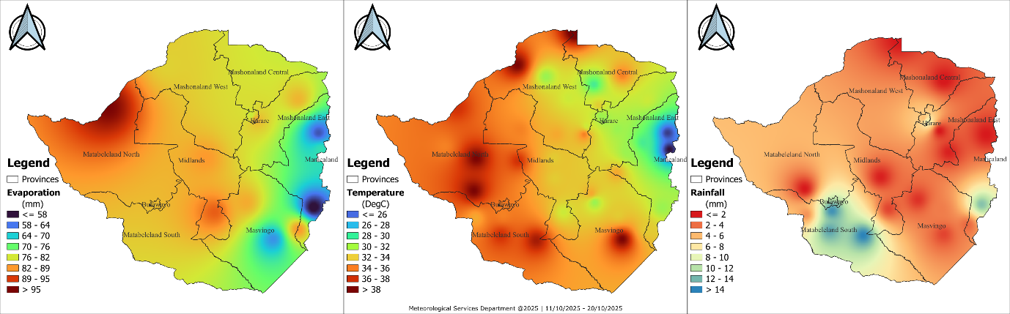
Fig 1: Evaporation, Maximum Temperature and Rainfall in the dekad ending 21-10-2025

The evaporation, temperature, and rainfall maps in Fig 1 show continued warm and mostly dry conditions. High evaporation values, especially across the western and southwestern parts of the country, corresponded with elevated temperatures exceeding 34°C in the same areas. Significant falls were mainly in parts of Matabeleland South and Manicaland. The spatial relationship indicated strong heat and moisture loss in drier regions, while areas with localized rainfall experienced slightly lower evaporation and temperatures.

WEATHER OUTLOOK: October 2025
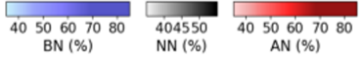  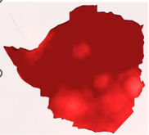 | 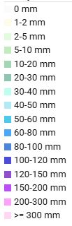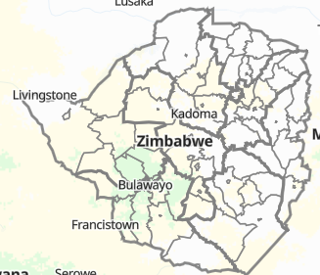  Fig 3: Weather outlook from 24-10-25 to 02-11-25. Courtesy https://prism.zwe.wfp.org/
Fig 2: Temperature Outlook for October

As illustrated in Figure 2, temperatures for October are forecast to be above normal across much of the country, as indicated by the widespread dark red on the map. Figure 3 shows the cumulative rainfall forecast for the last dekad of October, indicating that isolated thundershowers are expected in some areas. The 10-day rainfall total is projected to be less than 20 mm for most of the country, though localized downpours are probable.
Table 2: Provincial Weather outlook valid from 24-10-2025 to 02-11-2025
Province | Agromet -Weather forecast | Wind Direction  & Wind Speed  (knots) | Relative  Humidity  (%) | Min/Max  (°C)
Mashonaland Central | Partly cloudy and mild in the morning, becoming hot with isolated thundershowers in the afternoon. | NE’ly | 80-100 | 14-36
Mashonaland East | Partly cloudy and mild in the morning, becoming hot with isolated thundershowers in the afternoon. | NE’ly | 80-100 | 10-32
Mashonaland West | Partly cloudy and mild in the morning, becoming hot with isolated thundershowers in the afternoon. | NE’ly | 80-100 | 15-35
Harare | Partly cloudy and mild in the morning, becoming hot with isolated thundershowers in the afternoon. | NE’ly | 80-100 | 10-33
Midlands | Partly cloudy and mild in the morning, becoming hot with isolated thundershowers in the afternoon. | SE’ly | 80-100 | 10-33
Manicaland | Cloudy, cool, windy and drizzly conditions are expected in the morning becoming warm and mostly cloudy by afternoon on Tuesday 28 into Wednesday 29 October.  Partly cloudy and mild in the morning, becoming hot with isolated thundershowers in the afternoon for the other days of the dekad. | SE’ly | 80-100 | 08-27
Masvingo | Cloudy, cool, windy and drizzly conditions are expected in the morning becoming warm and mostly cloudy by afternoon on Tuesday 28 into Wednesday 29 October.  Partly cloudy and mild in the morning, becoming hot with isolated thundershowers in the afternoon for the other days of the dekad. | SE’ly | 80-100 | 12-34
Matabeleland North | Partly cloudy and mild in the morning, becoming hot with isolated thundershowers in the afternoon. | NE’ly | 80-100 | 14-36
Matabeleland South | Cloudy, cool, windy and drizzly conditions are expected in the morning becoming warm and mostly cloudy by afternoon on Tuesday 28 into Wednesday 29 October.  Partly cloudy and mild in the morning, becoming hot with isolated thundershowers in the afternoon for the other days of the dekad. | SE’ly | 80-100 | 11-34
Bulawayo | Cloudy, cool, windy and drizzly conditions are expected in the morning becoming warm and mostly cloudy by afternoon on Tuesday 28 into Wednesday 29 October.  Partly cloudy and mild in the morning, becoming hot with isolated thundershowers in the afternoon for the other days of the dekad. | SE’ly | 80-100 | 12-35

AGROMET ADVISORY
- Dryland Farming (Land Preparation & Input Procurement):
  - Advisory: This is a critical window for land preparation and securing inputs. Given the uncertain and isolated nature of the forecasted rainfall, farmers are strongly advised to consult with their local Agritex officers for personalized, location-specific guidance on the optimal timing for sowing and other management practices.
- Early Planted & Irrigated Crops (Maize and Tobacco):
  - Advisory: Farmers with irrigated maize and tobacco should continue with normal irrigation schedules to support crop growth, as the forecasted rain will provide negligible supplementary water.
- Advisory on Extreme Weather Events:
The potential for severe weather associated with isolated thunderstorms requires preparedness.
  - Localized Heavy Downpours: These can cause waterlogging in seedbeds, nutrient leaching in prepared fields, and rapid surface runoff leading to soil erosion. Ensure drainage systems are clear.
  - Lightning: This is a serious safety risk. Advise all farmers and workers to seek shelter indoors immediately when thunder is heard. Do not continue field operations during a thunderstorm.
  - Hail: Hail can cause significant physical damage to young, exposed crops and tobacco seedlings. Where possible, farmers with sensitive, high-value irrigated crops (like tobacco) should monitor forecasts and be prepared to use protective hail nets if available and feasible.
- General Recommendations:
  - Utilize Rainfall Events: While overall amounts will be low, any received rainfall can be beneficial for moistening seedbeds.
  - Monitor Official Forecasts: Stay updated with daily weather bulletins for signs of a significant shift in rainfall patterns.
  - Seek Expert Advice: Regular consultation with Agritex officers is recommended to navigate the current season's variability effectively.

