SATELLITE-BASED GLANCE INTO TODAY,  TUESDAY 28 JULY 2026    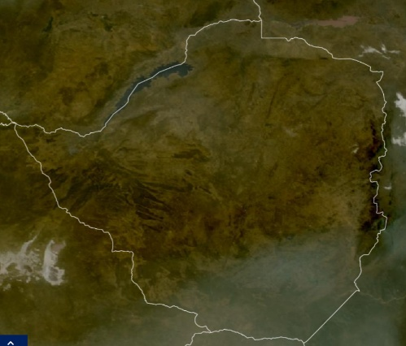 | The presence of dry air coupled with very cold conditions under clear skies overnight led to severe ground frost in Matopos (-3°C), moderate ground frost in Nyanga (-2°C), Gweru (-1°C), and Chivhu (-1°C). Slight ground frost occurred in Masvingo (0°C), West Nicholson (0°C), Chipinge (0°C), Rusape (1°C), Kezi (1°C), Plumtree (2°C), and Harare Belvedere (2°C). For the rest of the day, sunny and warm conditions were experienced countrywide. |  |   DRESS WARMLY | KEEP WARM  ESPECIALLY IN THE EARLY MORNING HOURS & OVERNIGHT. ENSURE YOUNG CHILDREN, THE ELDERLY, & PERSONS OF AN ILL DISPOSITION ARE KEPT WARM

FORECAST FOR TOMORROW: WEDNESDAY 29 JULY 2026
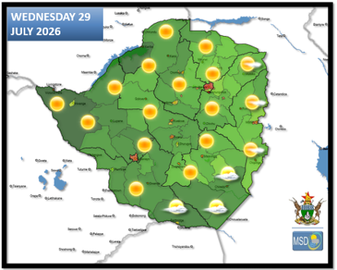 | Matabeleland South, Manicaland, South of Masvingo Province: | Briefly cloudy and cold at first, becoming partly cloudy and warm in the afternoon. Cold in the evening and overnight.
 | Harare Metropolitan, Bulawayo Metropolitan, All Mashonaland Provinces, Matabeleland North, Midlands: | Clear skies and cold conditions in the morning with ground frost in areas such as Buhera, Chivhu, Gwanda, Gweru, Kezi, Matopos, Nkayi, Nyanga, and Rusape. Sunny and warm in the afternoon becoming cold in the evening.
 | Actions to Take: | - Implement frost prevention measures where necessary, with advice from Agritex Officer.  - Monitor temperature within fowl runs and adjust accordingly, with advice from your local Agricultural Business Advisory Officer (ABAO).

WEATHER OUTLOOK FOR: THURSDAY 30 JULY 2026
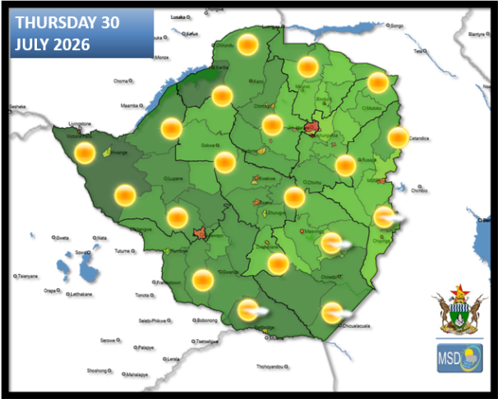 | ALL AREAS: | Clear skies and cold conditions in the morning with ground frost in areas such as Buhera, Chivhu, Lupane, Masvingo, Chipinge, Chimanimani, Gwanda, Gweru, Kezi, Matopos, Nkayi, Nyanga, and Rusape. Sunny and warm in the afternoon becoming cold in the evening.
 | Actions to Take: | - Implement frost prevention measures where necessary, with advice from Agritex Officers.  - Ensure the young and elderly are kept warm especially in the morning and overnight.

MAIN CITIES FORECAST: WEDNESDAY 29 JULY – SUNDAY 02 AUGUST 2026

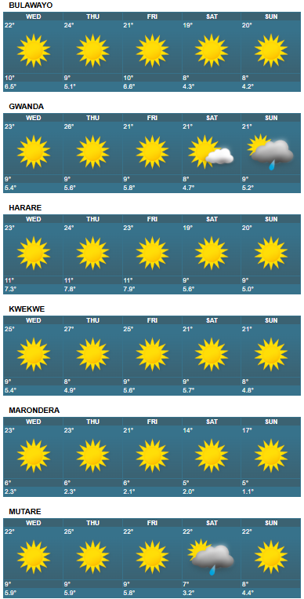
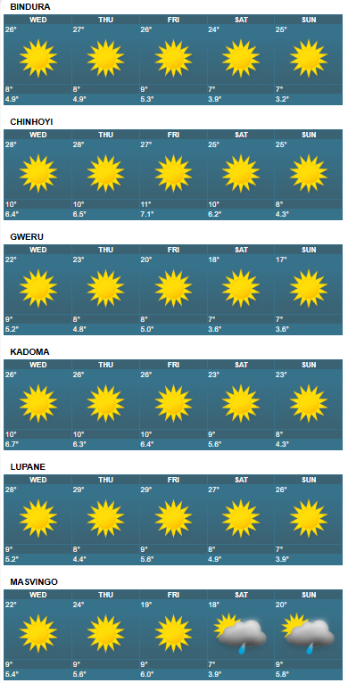

HOLIDAY RESORTS FORECAST: WEDNESDAY 29 JULY – SUNDAY 02 AUGUST 2026

